**Assignments on JavaScript**

**Submitted by- Sanket Bollamwar**

1. Write a program that asks the user for a number n and prints the sum ofthe numbers 1 to n

**Refer AssignmentQ1.html, AssignmentQ1.js files**

1. Modify the previous program such that only multiples of three or five are considered in the sum, e.g. 3, 5, 6, 9, 10, 12, 15 for n=17

**Refer AssignmentQ2.html, AssignmentQ2.js files**

1. Make a function that returns “even” or “odd” depending on the number passed to it. parity(1); --> "odd"

parity(2); --> "even"

**Refer AssignmentQ3.html, AssignmentQ3.js files**

1. Make a function that takes *number of flips* as parameter and returns the fraction that were heads

headsRatio(10); --> 0.7

headsRatio(10); --> 0.4

headsRatio(10000); --> 0.5023

headsRatio(10000000); --> 0.4999948

**Refer AssignmentQ4.html, AssignmentQ4.js files**

1. Write a program that prints the next 20 leap years.

**Refer AssignmentQ5.html, AssignmentQ5.js files**

1. Write a function that takes a list of strings and prints them, one per line, in a rectangular frame. For example the list ["Hello", "World", "in", "a", "frame"] gets printed as:

*********

* + Hello *
  + World *

* in *

* a *

* + frame *

*********

**Refer AssignmentQ6.html, AssignmentQ6.js files**

1. Create a Simple page that lets users enter a currency value in dollars and convert the value in other currencies.
   * 1. dollar is:
        1. 74.28 INR (Indian Rupee)
        2. 109.14 Yen (Japanese Yen)
        3. 0.84 Euro (Euro)
        4. 0.72 Pound sterling (Pound sterling)

**Refer AssignmentQ7.html, AssignmentQ7.js, AssignmentQ7.css files**

1. Write a function that concatenates two arrays [a,b,c], [1,2,3] -> [a,b,c,1,2,3]

**Refer AssignmentQ8.html, AssignmentQ8.js files**

1. Write a function that combines two lists by alternatingly taking elements E.g. [a,b,c], [1,2,3] -> [a,1,b,2,c,3]

**Refer AssignmentQ9.html, AssignmentQ9.js files**

1. Write a function that computes the list of the first 100 Fibonacci numbers. The first two Fibonacci numbers are 1 and 1. The n+1-st Fibonacci number can be computed by adding the n-th and the n-1-th Fibonacci number. The first few are therefore 1, 1, 1+1=2, 1+2=3, 2+3=5, 3+5=8.
2. Write function that reverses an array of random values, preferably in place.
3. Write a function that, given a string, will return the longest token (consecutive string of characters) that contains neither an a nor a b.

longestToken("ababcdababefgababhiab"); --> "efg" longestToken("aba"); --> ""

1. Write three functions that compute the sum of the numbers in an array: using
2. a for-loop,
3. a while-loop
4. a do-while-loop
5. Create an array containing 100 random numbers.
6. Print the largest number amongst the 100
7. Print the smallest number amongst the 100
8. Print which count is high even count or odd count
9. Print the sum and average value
10. Given an array of size 20 filled with random positive values. Implement the following sorting Algorithms:
11. Bubble sort
12. Merge Sort (Optional)
13. Create an HTML page that will Prompt the user:

It should take input for the number of rows and the number of columns

Then it should create a table (HTML table) with the given number of row and columns Each cell of the table should contain the cell id (row#, col#)

1. Write a function that rotates a list by k elements. For example [1,2,3,4,5,6] rotated by two becomes [3,4,5,6,1,2]. Try solving this without creating a copy of the list. How many swap or move operations do you need?
2. Write function that translates a text to Pig Latin and back. English is translated to Pig Latin by taking the first letter of every word, moving it to the end of the word and adding ‘ay’.

E.g. “The quick brown fox“ becomes “Hetay uickqay rownbay oxfay”

1. Design a simple calculator with a TextField and buttons for values 1,2…9,0 and symbols +,-

,*,/ & =. Clicking on the button to display the content on the textfield and clicking the button with = should display the result

e.g. clicking buttons with labels 2, +, 2 should show on the textfield “2 + 2” and when hit the button with equals sign should result as 4. Also, there should be a clear button to clear the textfield

1. You are asked to build a page to order pizza! The page asks the user to enter information regarding the pizza order and then see a summary of what have been entered. The page is static HTML; however, part of the page will be dynamically built as it will be explained below.

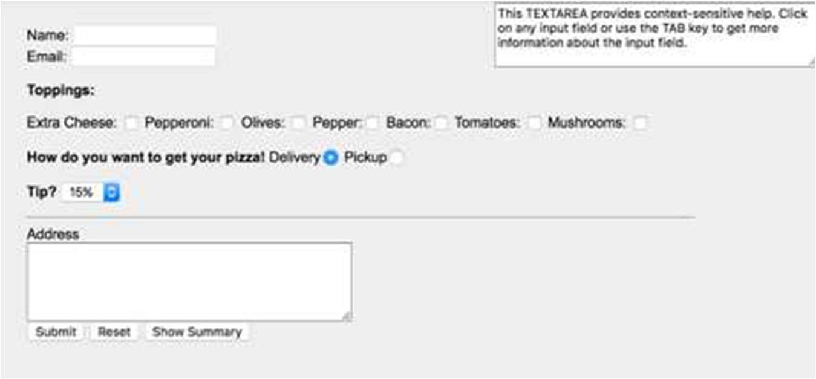

# Figure 1

The page consists of the following fields:

1. Customer Name & Email (Input fields)
2. Toppings Options (Check Boxes)
3. Delivery method (Radio Buttons)
4. Tip amount (Drop Down Menu), values are 15%, 20%, and 25%
5. Address (Text Area)
6. Action Buttons
7. Help Text (Text Area)
8. Summary of Order (Table)

All the fields are static fields except the last one (Summary Table) which is built based on the values entered by the user.

This page should implement the following actions (see Figure 2):

* 1. The Help Text (Field # 1 in Figure 2) is responsible of showing a Hint message to explaining information about the field that is currently focused (cursor is on the field). If there is no focus on any field, display a default hint message. Messages are displayed on (Table 1).
  2. Submit Button should check that all fields are filled otherwise display an error message indicating that there exist missing values.
  3. Clear All: Clear All fields.
  4. Show Summary: This button is initially disabled. It is enables only when submit button is pressed and all fields values are valid. Clicking this button should build

the Summary Table (see #2 in Figure 2). The table will summarize the pizza order based on what have been filled.

The table should show:

Customer Name:

Customer Email:

Customer Address:

Toppings Selected:

Delivery Option:

Total Price: Based on formulae (base price + 1.5 * number of toppings + delivery fee) *

1.0 + tip

Where: base price= 10 and delivery is 5.

For example, if 3 toppings are selected, delivery is NOT checked and 20% tip is selected, total is (10 + 1.5 * 3 + 0) * 1.2 = $17.4